
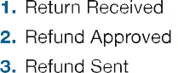
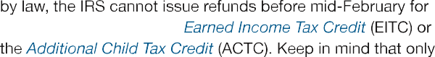
s
IRS Pub 2043

To check Iowa Refunds: https:///www.idr.iowa.gov/wheresmyrefund

